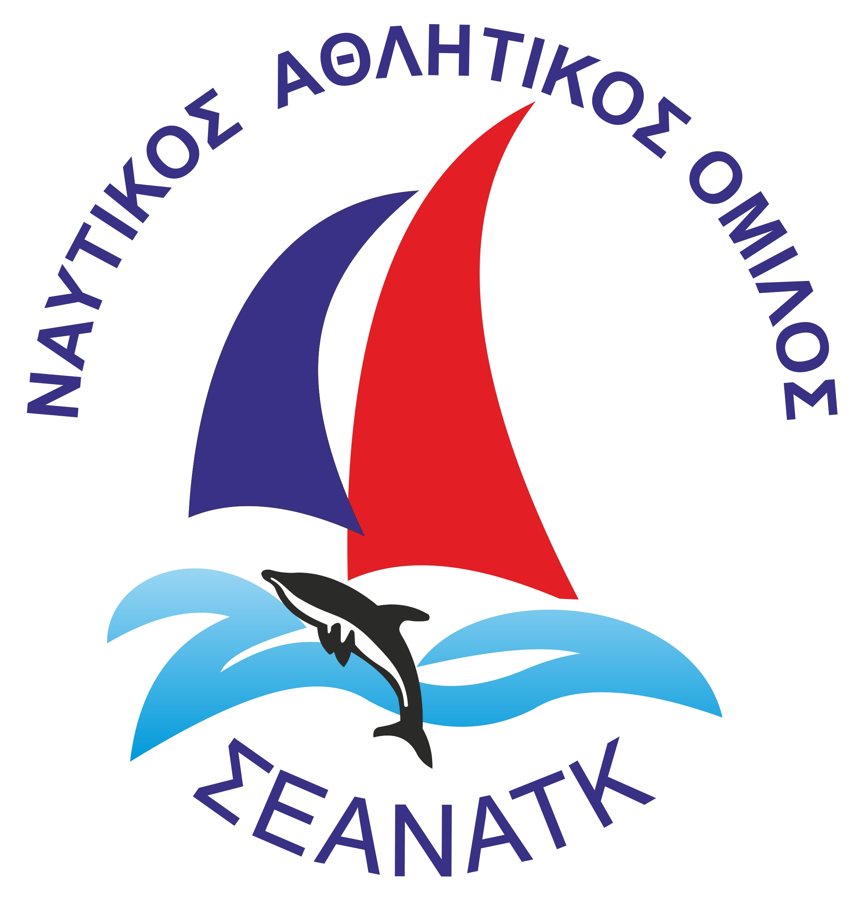 | ΠΑΡΑΚΤΙΑ ΣΕΑΝΑΤΚ 2018  14/7/2018

RESULTS - STARTING TIME 10:31 DISTANCE: 17.73 NM  SCORING: ToT – Coastal / Long Distance | Class : NS

Overall Pos | Yacht Name | Sail No | Division | Finish Time | Elapsed | Corrected
1 | MELODIE | GRE-49150 |  | +0 17:55:05 | 07:23:55 | 05:27:55
2 | ΝΕΜΟ | GRE-1288 |  | +0 18:14:32 | 07:43:22 | 06:09:46
3 | NATALIA Α | GRE-49393 |  | +0 18:35:40 | 08:04:30 | 06:10:30
4 | ANTHIIS | GRE-49571 |  | +0 19:12:02 | 08:40:52 | 06:11:20
5 | ALMYRA | GRE-1505 |  | +0 19:04:02 | 08:32:52 | 06:11:34

